Practical 14: Sales Data Workbook

Aim

To analyze sales data using Excel formulas and charts.

Objectives
• To use SUMIF formulas
• To filter categories

Materials Required
• Excel

Procedure

1. Enter or import sales data – Add sales records manually or import them from an external file to build your dataset.

2. Sort and filter – Organize the data by sorting and apply filters to focus on specific products, dates, or regions.

3. Use SUMIF – Apply the SUMIF function to total sales based on a chosen condition, such as product type or salesperson.

4. Extract text using LEFT/RIGHT – Use LEFT or RIGHT functions to pull specific characters from product codes or IDs.

5. Create line chart – Plot a line chart to visualize sales trends over time for clearer analysis.

6. Protect sheet – Lock the sheet or specific cells to prevent unauthorized edits and maintain data integrity.

STORE SALES:
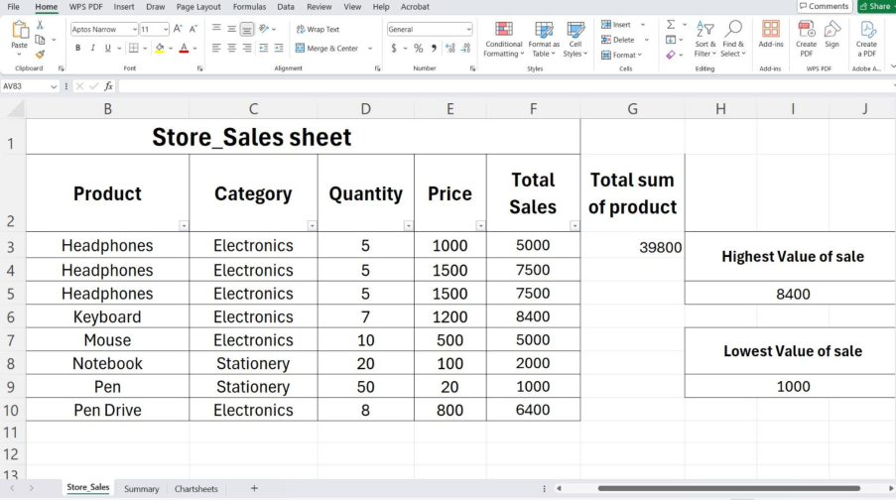

SUMMARY :
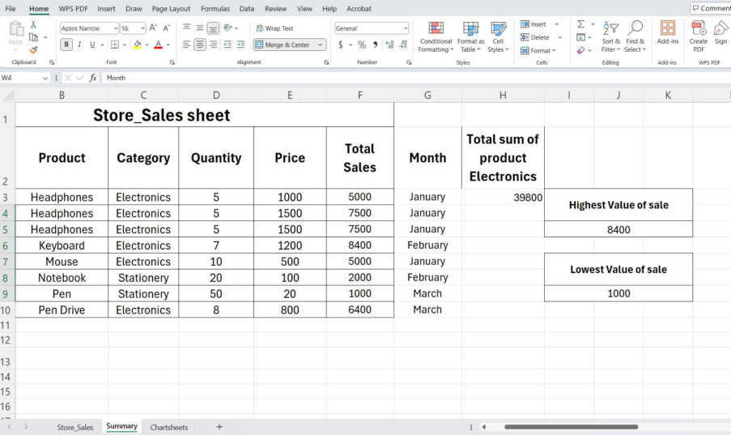

CHART SHEET :

